Mini Project Report

**“Smart Blind man stick project”**

**Submitted as part of CIE for the subject**

**Sensors and Actuators**

By

*Rekha Myali 1NT16CS089*

*Bhavya Bannadabhavi 1NT16EE007*

*Pinki 1NT16CS071*

Under the Supervision of

**Dr. Veda Sandeep Nagaraja**

Associate Professor

Department of Electronics and Communication Engineering

Nitte Meenakshi Institute of Technology

**Academic Year**

2018- 2019

**Introduction**

This walking stick is an alternative to the traditional walking stick. Here, Arduino UNO , ultrasonic sensor, LCD display and voltage regulator are used. Arduino is a microcontroller which can do all the calculations very fastly and quickly with great accuracy. Ultrasonic sensor is used to detect the object in the front of the person by measuring the distance between the object and the stick. For left and right object detection, IR Sensor is used which is very small in range. So, it detects the object which are very close. Using more ultrasonic sensor may create calculation problem. The voice playback module will assist the blind person to reach the destination through the command or microphone.

According to the WHO, about 30 million people are estimated to be permanently blind worldwide. These people are totally dependent on others. They even cannot walk on their own. We have created designed and built an “Ultrasonic Blind Walking Stick” device which will help blind people to walk with ease independently. As a simpler version, we have used only one ultrasonic sensor in this project. For better accuracy

and assistance two or three sensors can be used.

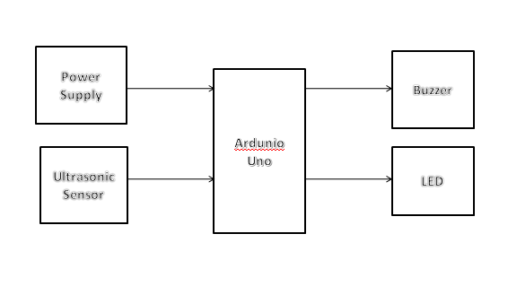

**Block Diagram :**

**Objectives:**

The main Objective of this project is as follows:

* To help visually challenged people to navigate with ease using advance technology. In this technology controlled world, where people strive to live independently, this project proposes an ultrasonic stick for blind people to help them gain personal independence. Since this is economical and not bulky, one can make use of it easily.
* Nowadays in this complicated world one cannot depend on other for his activities. But when we look for blind person it is highly difficult to survive them alone, since they are not able to walk alone in the road. But this project help the blind person to stand or walk alone without depending on others.
* If every blind person in this world they have a guilt that they are not able to walk alone .But if every blind person use this stick they may overcome from their problem. And walk independently without depending on others

**Motivation and Problem Approach:**

In this work, most of the problems that may face the blind people are solved like

the barriers or people in front of him at a certain distance because they may cause a

collision. The other problem is due to the presence of ponds that may immerse the feet

of the blind in it and cause injuries too. In addition, holes or stairs in the way of the

blind that will cause him to fall are another problem. Here the solutions to these

problems are made and it differs from the others by the following points:

The first one is that previous studies did not solve the existence of a hole in

front of the blind, causing fractures in the bones or other injuries that will studied in

this work.

While, the second one is that all scenarios implemented practically and gave

good results in addition to previous theoretical or simulated studies

**Explain in detail how and why you took this project, how you approached it:**

A variety of future scope are available that can be used of with the stick such as usage of Global positioning System can help the blind person to source to destination route information. GPS can help to find the shortest and best path as accordingly to Google ( Bing map based on real time coordinates). GSM attachment can help in future for any immediate casualty help. It can also contain special arrangement to connect the walking stick to aadhar card of blinds, helping the government serve the physically disable even better. Water sensor that sense any kind of water allowing the safe walk of the blind people in order to avoid slipping .

The working behind this blind stick is that it is used for special purpose as a sensing device for the blind people. The circuit provides 5V power supply for the circuit and maintains its output of the power supply at constant level. It is used widely to detect objects using ultrasonic sensor and IR sensor. If any object is present, the ultrasonic sensor detects the object by measuring the distance between the object and the user and sends the data to the arduino UNO. To determine the distance of an object , calculate the distance between sending the signal and receiving back the signal.

*Distance=speed*time

The speed of the signal travelling through air is 341m/s. The time is calculated between the sending and receiving back the signal. Since the distance travel by the signal is double, it is divided by two i.e.,

Distance=*Distance/2 IR sensor is placed at right and left of the stick to detect the object. Since, it is very small range, it detects the closer objects. Arduino processes with this data and calculates with the command conditions. If any object is found nearer, it sends the command to the user through the speaker or microphone. The command is already stored in the voice playback module which sends alert message to the user about the object.

**Outcome**

The Blind Walking Stick has been finally made into prototype which can be used to guide the blind . Its aims to solve the problems faced by the blind people in their daily life. The system also takes the measure to ensure their safety . This project will operate to help all the blind people in the world to make them easier to walk everywhere they want. It was done to help the blind to move infront very well. It is used to help the people with disabilities that are blind to facilitate the movement and increase safety.

REFERENCES:

* Osama Bader AL-Barrm International Journal of Latest Trends in Engineering and Technology(IJLTETJ)
* Smart Cane Assisted Mobility for the Visually Impaired, World Academy of Science, Engineering and technology International Journal and Information Engineering Vol:6 No:10,2012
* J.B.F. van Erp, J.A. Veltman, H.A.H.C. van Veen (2003): A Tactile Cockpit Instrument to support Altitude Control, Proceedings Human Factors and Ergonomic Society 47tn annual meeting 2003.
* G. Prasanthi and P. Tejaswidho Sensor assisted Stick for the Blind People-Transmission on Engineering and Sciences, vol:3,number 1, pp-, 12-16,2015.
* I .Ulrich, J. Borenstein, The GuideCane –Applying Mobile Robot Technologies to Assist the visually impaired, IEEE Tr.SMC, Vol:31, No.2, March 2001.
* S. Shovel, J. Borenstein, Y. Koren, Auditory guidance with the Navbelt-a computerized travel aid for the blind, IEEE Tr. SMC, Vol.28, August 1998.